1. **Before the home work, we should read the file:**

Read a csv file:

bear <- read.csv('bears.csv')

1. **Create a strip chart for each possible numeric variable (there should be 7). Use jitter. Include the R code above each graph in a Word Document.**

By age stripchart:

stripchart(bear$age, method = 'jitter', main = 'Age', xlab = 'year', cex = 1.0)

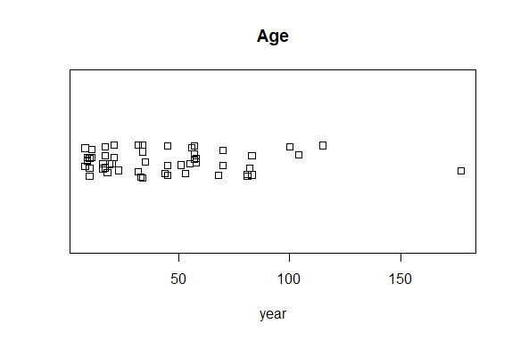

By head length stripchart:

stripchart(bear$headlength, method = 'jitter', main = 'Head length', xlab = 'inches', cex = 1.0)

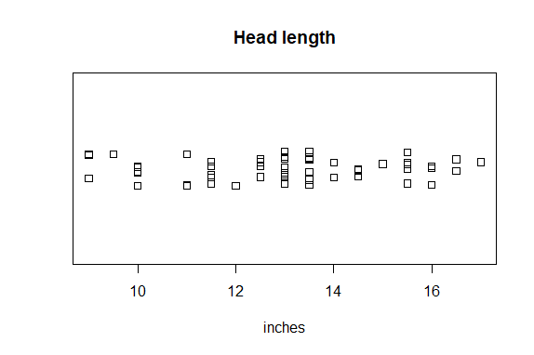

By head width stripchart:

stripchart(bear$headwidth, method = 'jitter', main = 'Head width', xlab = 'inches', cex = 1.0)

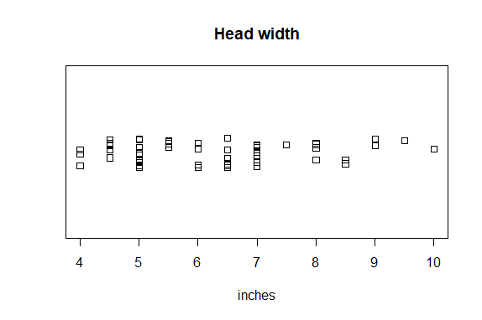

By Neck circumference stripchart:

stripchart(bear$neckcircum, method = 'jitter', main = 'Neck circumference', xlab = 'inches', cex = 1.0)

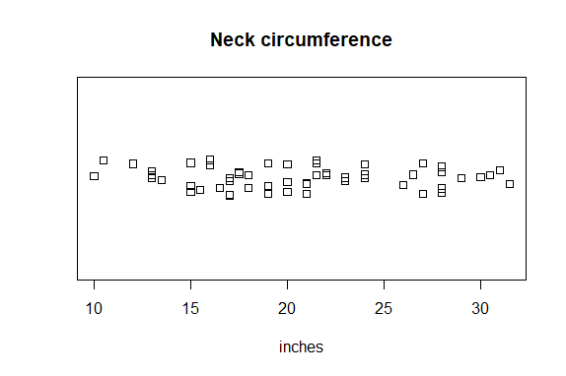

By length stripchart:

stripchart(bear$length, method = 'jitter', main = 'Length', xlab = 'inches', cex = 1.0)

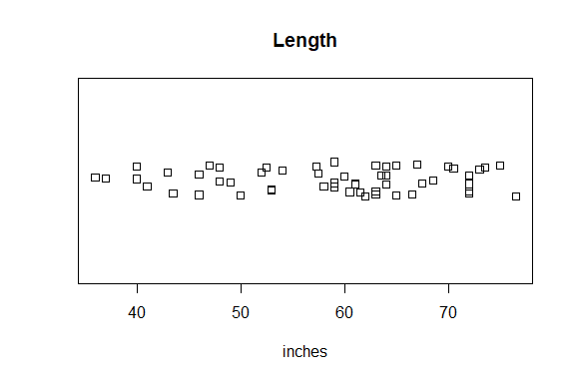

By chest stripchart:

stripchart(bear$chest, method = 'jitter', main = 'Chest', xlab = 'inches', cex = 1.0)

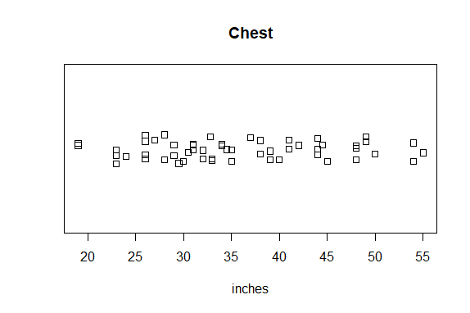

By weight stripchart:

stripchart(bear$weight, method = 'jitter', main = 'Weight', xlab = 'pounds', cex = 1.0)

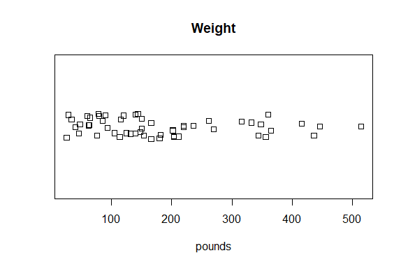

1. **In the same Word Document, create a sorted dot chart of the following (3 graphs) using gender as the row label. Include the R code above each graph:**

**A. the length**

**B. the chest**

**C. weight**

Hence, I should sort the raw data at first:

By length dotchart:

length_order <- bear[order(bear$length),]

dotchart(length_order$length, labels = bear$gender, cex = 0.7, main =

'Length compare with gender', xlab = 'Length(inches)',

ylab = 'Gender', cex.main = 2, cex.lab = 1.5, pch = 19,

col = c('darkred', 'blue'))

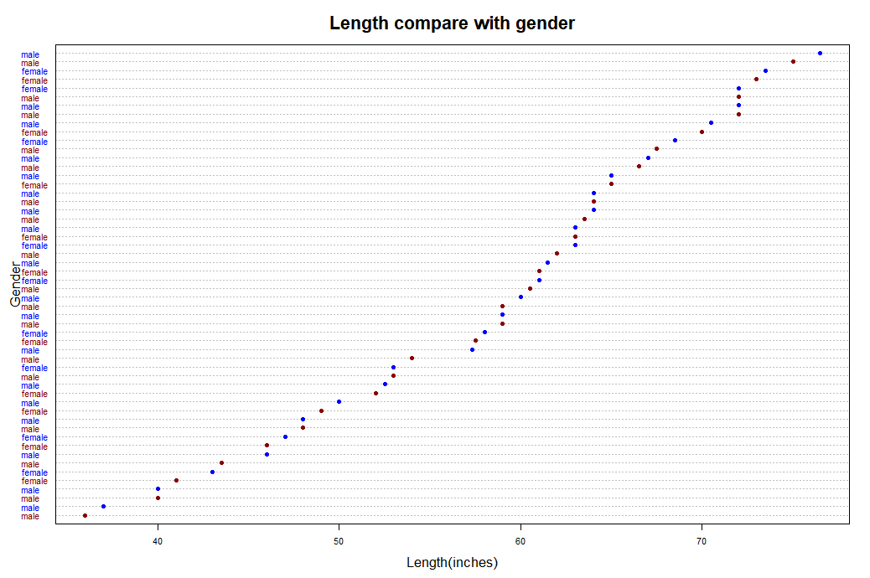

By chest dotchart:

chest_order <- bear[order(bear$chest),]

dotchart(chest_order$chest, labels = bear$gender, cex = 0.7, main =

'Chest compare with gender', xlab = 'Chest(inches)',

ylab = 'Gender', cex.main = 2, cex.lab = 1.5, pch = 19,

col = c('darkred', 'blue'))

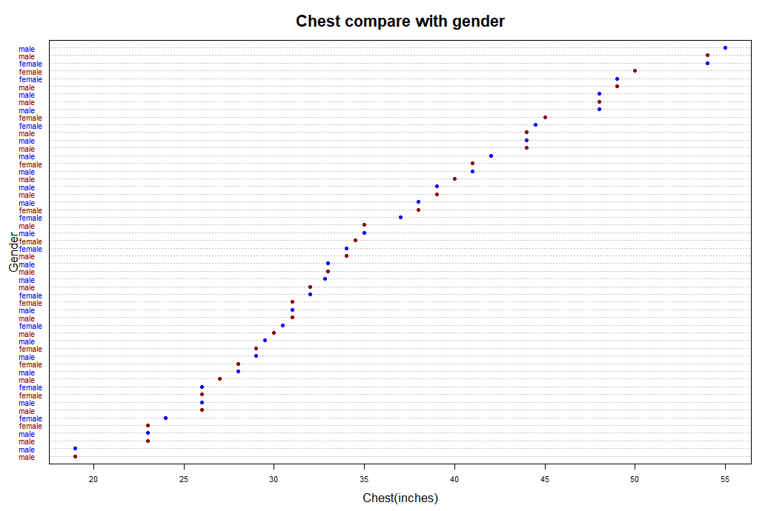

By weight dotchart:

weight_order <- bear[order(bear$weight),]

dotchart(weight_order$weight, labels = bear$gender, cex = 0.7, main =

'weight compare with gender', xlab = 'Weight(pounds)',

ylab = 'Gender', cex.main = 2, cex.lab = 1.5, pch = 19,

col = c('darkred', 'blue'))

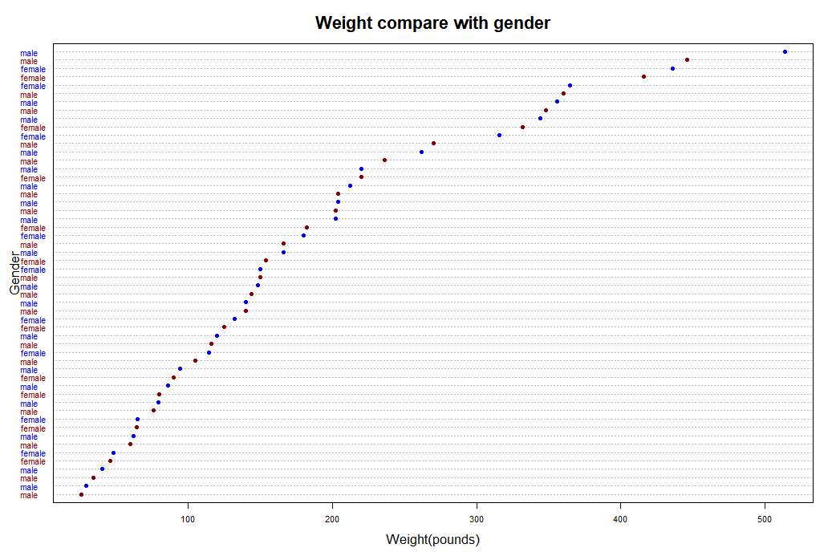

1. **In the same Word Document, create box plots for each of the 7 numeric variables separated by gender. There should be 7 pairs of side-by-side boxplots giving you 14 in total. Include the R code above each graph. Below each graph, thoroughly explain in complete sentences what you observe in each of the box plots. Use summary() to help obtain precise numbers.**

By age boxplot:  
boxplot(bear$age~gender, data = bear, col = c('deeppink1', 'deepskyblue3'),

main = 'Age group by gender', xlab = 'Gender',

ylab = 'Age(year)', cex.main = 2, cex.lab = 1.5)

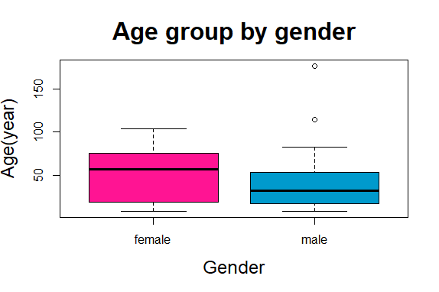

By head length boxplot:

boxplot(bear$headlength~gender, data = bear, col = c('deeppink1', 'deepskyblue3'),

main = 'Head length grouop by gender', xlab = 'Gender',

ylab = 'Head length(inches)', cex.main = 2, cex.lab = 1.5)

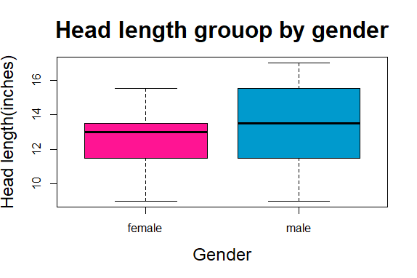

By head width boxplot:

boxplot(bear$headwidth~gender, data = bear, col = c('deeppink1', 'deepskyblue3'),

main = 'Head width group by gender', xlab = 'Gender',

ylab = 'Head width(inches)', cex.main = 2, cex.lab = 1.5)

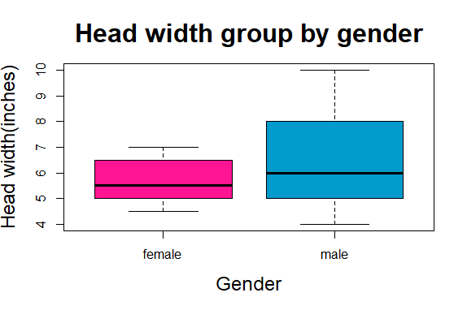

By neck circumference boxplot:

boxplot(bear$neckcircum~gender, data = bear, col = c('deeppink1', 'deepskyblue3'),

main = 'Neck circumference group by gender', xlab = 'Gender',

ylab = 'Neck circumference(inches)', cex.main = 1.8, cex.lab = 1.5)

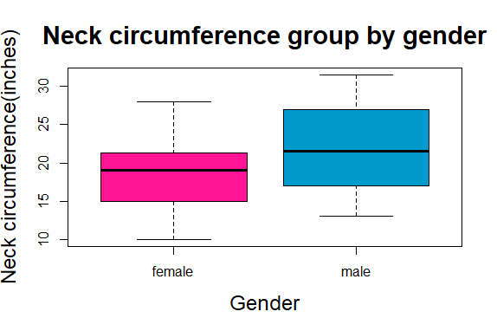

By length boxplot:

boxplot(bear$length~gender, data = bear, col = c('deeppink1', 'deepskyblue3'),

main = 'Length group by gender', xlab = 'Gender',

ylab = 'Length(inches)', cex.main = 2, cex.lab = 1.5)

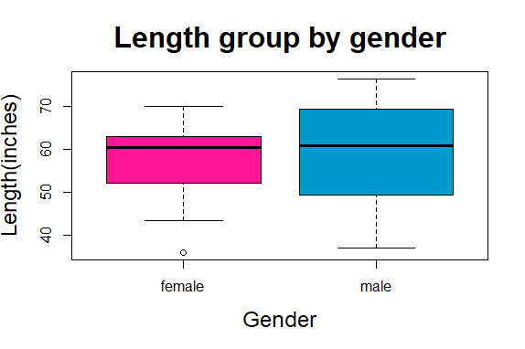

By chest boxplot:

boxplot(bear$chest~gender, data = bear, col = c('deeppink1', 'deepskyblue3'),

main = 'Chest group by gender', xlab = 'Gender',

ylab = 'Chest(inches)', cex.main = 2, cex.lab = 1.5)

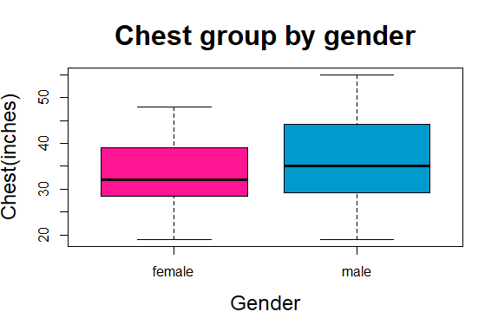

By weight boxplot:

boxplot(bear$weight~gender, data = bear, col = c('deeppink1', 'deepskyblue3'),

main = 'Weight group by gender', xlab = 'Gender',

ylab = 'Weight(pounds)', cex.main = 2, cex.lab = 1.5)

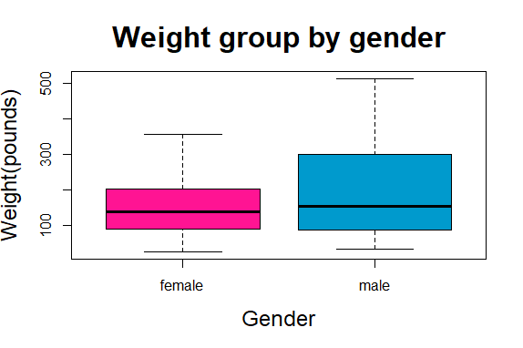

1. **Extra from 2.**

I want to make the ‘female’ item from ‘gender’ to be the color 'Darkred'; the ‘male’ item from ‘gender’ to be another color 'Blue', SO, I search the information online and introduce a function ‘ifelse’ that can achieve my expectation:

By length dotchart:

bear$color <- ifelse (bear$gender == 'female', 'darkred', 'Blue' )

dotchart(length_order$length, labels = bear$gender, cex = 0.7, main =

'Length compare with gender', xlab = 'Length(inches)',

ylab = 'Gender', cex.main = 2, cex.lab = 1.5, pch = 19,

col = c(bear$color))

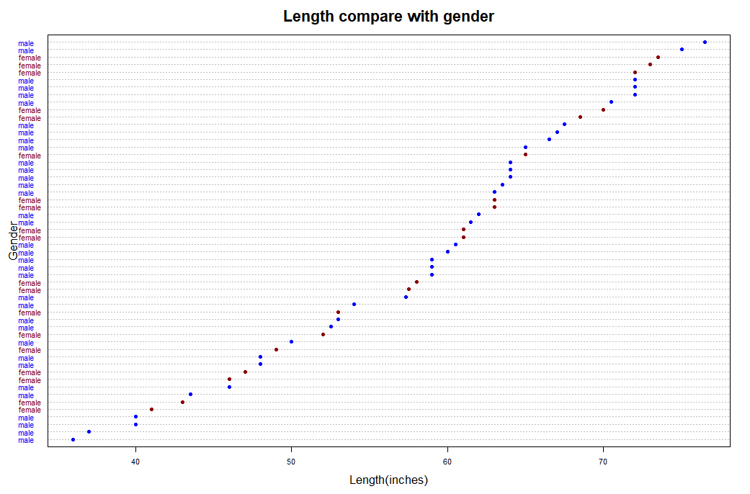

By chest dotchart:

dotchart(chest_order$chest, labels = bear$gender, cex = 0.7, main =

'Chest compare with gender', xlab = 'Chest(inches)',

ylab = 'Gender', cex.main = 2, cex.lab = 1.5, pch = 19,

col = c(bear$color))

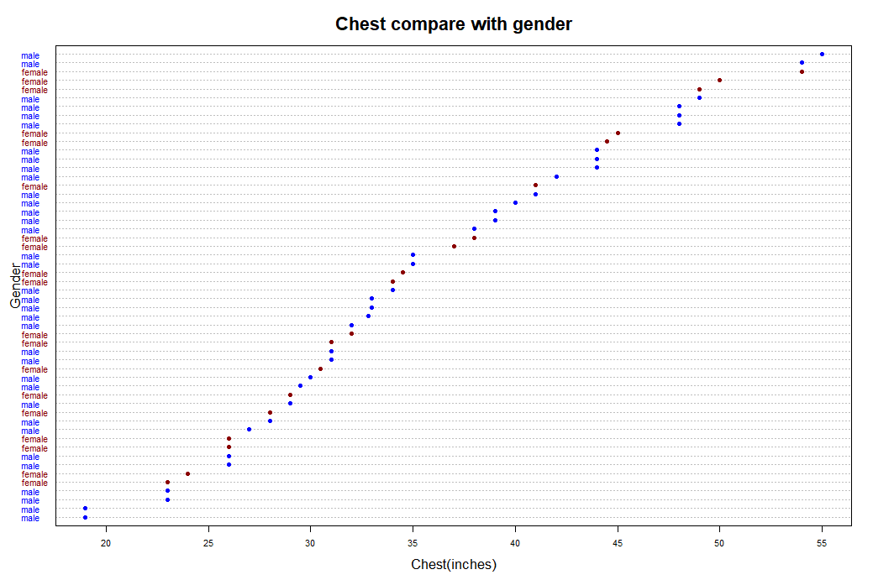

By weight dotchart:

dotchart(weight_order$weight, labels = bear$gender, cex = 0.7, main =

'Weight compare with gender', xlab = 'Weight(pounds)',

ylab = 'Gender', cex.main = 2, cex.lab = 1.5, pch = 19,

col = c(bear$color))

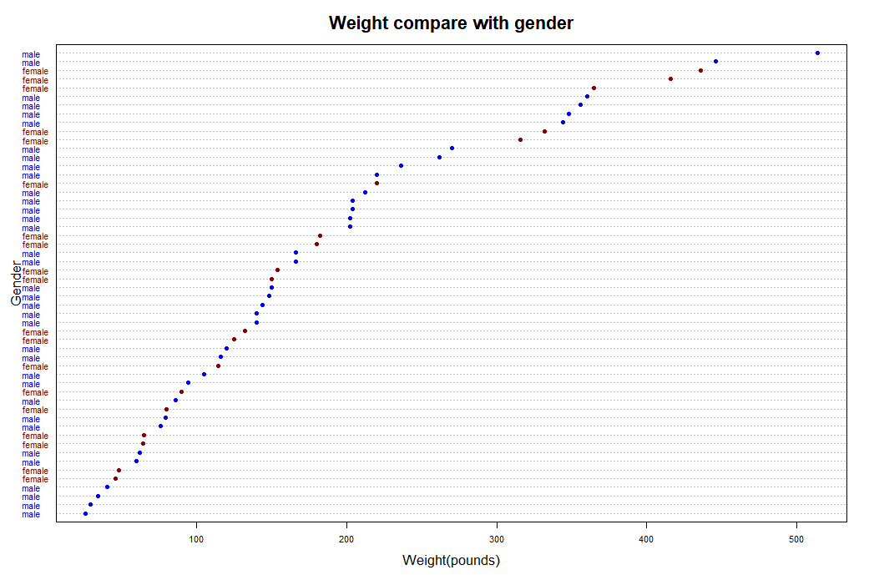

~The End~